Recovering Fonthill 1560-2014
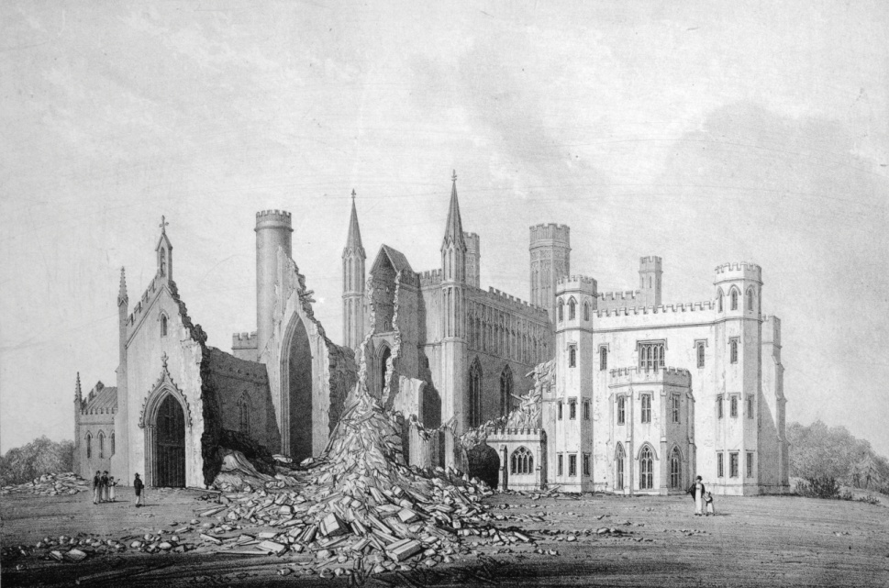
A two day symposium at Central Saint Martins in London on Friday 12 September and at the Fonthill estate in Wiltshire on Saturday 13 September 2014
Fonthill is most often associated with the eccentric bisexual William Beckford who built a vast Gothic abbey at the end of the eighteenth century as a retreat from the censorious public. His exotic life-style, acted out in a pleasure ground surrounded by a barrier twelve feet high was the subject of gossip even before losses in the family’s sugar plantation in Jamaica forced him to sell both the abbey and many of his fabulous treasures. Then the dramatic collapse of the tower in 1825 transformed the name Fonthill into a symbol for over-arching ambition and folly, a sublime ruin. Fonthill is, however, much more than the story of one man’s excesses.
Over 350 years the name was repeatedly synonymous with notoriety, wealth and dilettantism. In the 17th century the house was the stage for Lord Castlehaven’s gross immoralities and the country retreat of Charles I’s crypto-catholic Lord Chancellor, Francis Cottington. In the 18th century Alderman Beckford used his huge sugar fortune to build a new Palladian mansion later demolished by his son. In the 19th century the younger Beckford was followed by the Grosvenors and the Morrisons, both hugely rich, who built and landscaped and collected. Not just houses have gone: the landscape itself has been changed, rivers dammed, lakes widened, canals and elaborate water gardens dug and filled in. Temples, bridges, gatehouses, grottos, statuary, all have disappeared or been reduced to ruin.
Apart from the role of William Beckford, virtually all this complicated and rich story has been un-researched because the estate has always been and still is private. The purpose of this symposium is to begin to redress the balance, to examine the rich cultural heritage of this extraordinary estate. The owners have agreed access: the possibilities for original research are exciting. The symposium will bring together a number of established and younger historians, architects, restorers, conservators and curators who are engaging in various aspects of the wider Fonthill story. The approach is interdisciplinary: connections will be made between the landscape, buildings, interiors and objects.
The first day will be in the new building of Central Saint Martins at Kings Cross, designed by Stanton Williams and incorporating the old granary of the Great Northern Railway. This is an appropriate location both because of its manifestation as an example of architecture that engages with the ‘recovery’ of buildings but also its educational history stretching back to Lethaby. And like Fonthill, CSM is surrounded by change, the old railway landscape fast disappearing beneath 21st century commerce. Papers will include: ‘Francis Lord Cottington’sFonthill’, ‘Putting together Alderman Beckford’s Splendens’, ‘The “making” of William Beckford’, ‘Restoring Alderman Beckford’s Organ’, ‘Treasure-hunting: locating Beckford’s collection’, ‘The Lanes: Grotto Builders’, ‘The Morrisons’ Pavilion’, ‘Little Ridge and Detmar Blow’.
The second day will be at Fonthill walking across the private landscapes, with access by kind permission of the current owners. We shall be attempting to understand the locations of some of the lost houses, but also visit surviving remnants, including Beckford’s Abbey, his stables and boathouse, the Palladian Arch (of disputed provenance), the remains of Detmar Blow’s Little Ridge and the traces of work by William Burn, George Devey and Papworth visible only in estate cottages and lodges. There will be an opportunity to visit the archives of the Morrison family where a special display will be presented by the estate’s archivist.The symposium will be opened by Professor Jeremy Till, Head of Central Saint Martins. Speakers include Neil Burton, Caroline Dakers, Michael Drury, Suzannah Fleming, Amy Frost, Dominic Gwynne, Philip Hewat-Jaboor, Lawrence Klein, Martin Levy and Michael Symes; the tour of Fonthill will be led by Caroline Dakers, John D’Arcy, Amy Frost and Min Wood.
-----------------------------------------------------------------------------------------------------------------------------------
Tickets for the first day are £40.00 (£20 for students) to include coffee, tea, lunch and evening reception drink. Numbers are restricted on the first day to a total of 80. 5 student tickets at £20 will be reserved until one month before the symposium.Tickets for the second day are £40 and cover return coach from London (Bedford Square) to Fonthill in Wiltshire, coffee, tea and lunch. Numbers are restricted on the second day to a total of 50. 5 student tickets at £20 will be reserved until one month before the symposium.
Please pay on-line via the University of the Arts London eStore: http://estore.arts.ac.uk/browse/extra_info.asp?compid=1&modid=2&deptid=174&catid=69&prodid=140.
Steps for booking:
1, Click on the above link to go to the UAL eStore.
2, Click the ‘Book Event’ button
3, If you have never used the eStore before you will be required to register. Click on the red text in the ‘If this is your first visit click here’ message and follow the instructions. Otherwise log in with your username and password.
4, Once you have registered/logged in, select if you wish a day one or two ticket. If you wish to attend both days, please select day one for now, you will be able to add the day two ticket later in the order. Once you have selected the desired ticket press the green continue button.
5, Click the grey ‘Use my Customer Details’ button in the top right corner to populate the delegate details and then click the green continue button.
6, Click the green continue buttonagain, and then indicate if there are any special access requirements before clicking the green continue button onceagain.
7, You will now be on the Booking Summary screen. If there are no more tickets to be purchased please click the green ‘Add to Basket’ button and proceed to payment. If you want to add more delegates to the booking, or as mentioned in step 4 wish to purchase an additional ticket for day two of the event, please click the grey ‘Add Delegate’ button at the bottom to add more people/tickets to the booking.
Please note that when you repeat step 5 for the additional tickets you will need to fill in the delegate details appropriate to the additional person, however you can just input a generic institution address rather than a personal address for each delegate.
In case of difficulties email c.dakers@csm.arts.ac.uk
The symposium is supported by the Culture and Enterprise Programme at Central Saint Martins (University of the Arts London), the owners of the Fonthill Estate and the Old Fonthill Abbey Estate and with an education grant from the Paul Mellon Centre.

