CONVERSATIONS

WITH BECKFORD

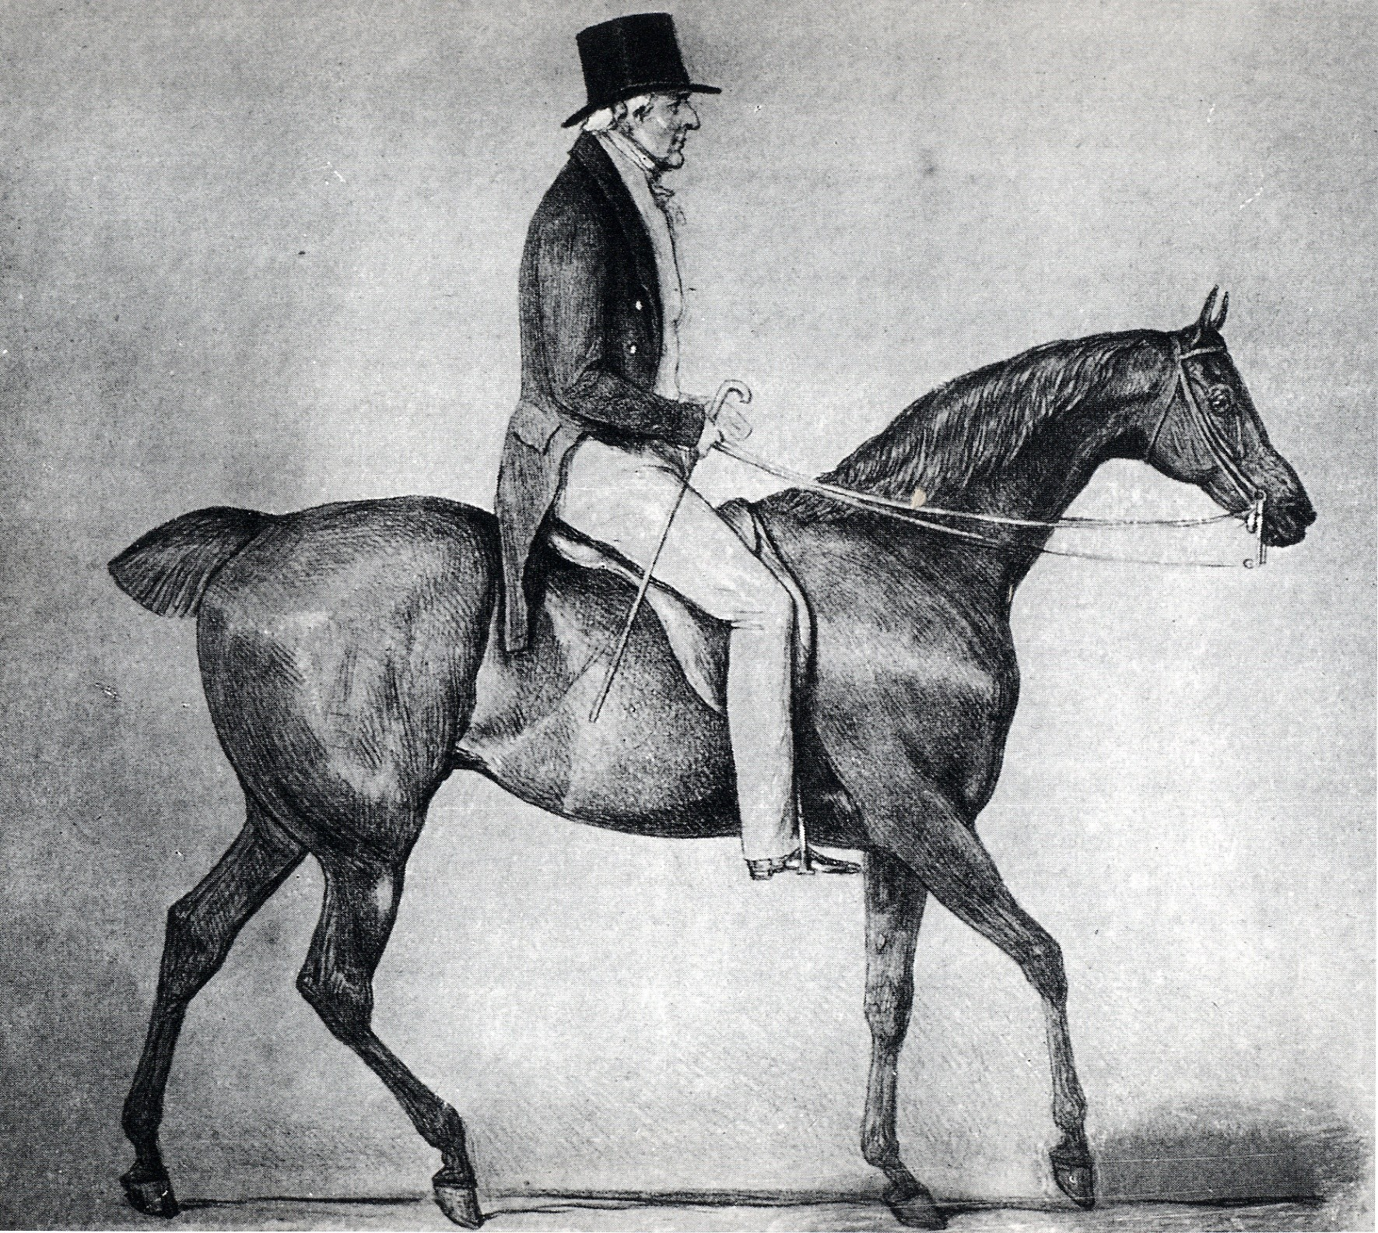

MEMOIRS OF WILLIAM BECKFORD
FROM THE NEW MONTHLY MAGAZINE 1844

Shortly after William Beckford’s death in May 1844, the New Monthly Magazine published a series of recollections of him by Cyrus Redding, ‘H’ a local artist, and William Henry Harrison. These memoirs portray the last decades of Beckford’s life with a marvellous immediacy.

His voice was agreeable, his manner energetic, and when he became excited by conversation, and he allowed his imagination full play, knowledge and persuasion, sublime images and sarcasms, came flooding from his lips in such a powerful stream, that you were forcibly carried by it to the sands of admiration, and there left to bask in the splendour of his genius.

CONVERSATIONS WITH BECKFORD reproduces in facsimile the original articles from the New Monthly Magazine. The introduction and index of names is by JON MILLINGTON, author of William Beckford: A Bibliography (2008), and founding editor of the Beckford Journal.

102 pages. 220 x 138 mm. Paperback.
£6/$10

TO BE PUBLISHED NOVEMBER 2013
ISBN 978-0-9537836-6-3

Please send me …… copy/copies of Conversations With Beckford @ £6/$10 per copy. I enclose a cheque/check for £/$ …. . made payable to the International Beckford Society. Payment may also be made by PayPal to sidney.blackmore@btinternet.com.

NAME …………………………………………………..

ADDRESS …………………………………………………
………………………………………………………………..
………………………………………. POSTCODE ……………….
EMAIL ……………………………

Postage free within UK. For Europe, please add £3.50/$5.50; and for outside Europe £4.50/$7 per copy.

PLEASE SEND COMPLETED FORMS TO
SIDNEY BLACKMORE, THE TIMBER COTTAGE,
CROCKERTON, WARMINSTER BA12 8AX. UK

